**Opening a Coffee Shop in Manhattan—with some help from Python and Foursquare**

Introduction:

New York City is a massive place and since there are so many different types of shops and restaurants in such a dense environment it can be difficult for someone with a great new concept to identify where to locate. One important aspect of that decision is understanding how many competitors there are in an area. I use python and the Foursquare API to identify neighborhood venues and then find out how competitive an area is for a new coffee shop as well as how many other venue types there are and then recommend a neighborhood to set up at.

Data:

I used python, the lab’s New York City Borough and Neighborhood data and the Foursquare location data to answer this question. Specifically, used the venue type as well as the longitude and latitude data from Foursquare in combination with the neighborhood data to identify which type and how many venues are present in each neighborhood.

Methodology:

I used the Foursquare API in combination with the location data from the lab to identify the venues in each neighborhood. This data was then turned into two key components: the number of overall venues in an area, which I used as a proxy for how busy or how populous a neighborhood is, and also the ratio of coffee shops to other venues. I used the onehot method to find the ratio. Then matplotlib was used to put the results into charts of easier to understand results.

Results / Discussion:

The results showed that there is a wide variety of coffee shop coverage in the neighborhoods. Harlem in particular did not have any coffee shops identified by foursquare at all! The total number of venues was not as helpful as I had hoped due to a limitation with the foursquare API that capped the number of venues at 100 per neighborhood call. Despite this, I think that the ratio of coffee shop to other type of venues is still a helpful metric and there is no reason to think that increasing the venue results would significantly change the ratio. The total number of venues was still helpful in that it did show that the two Harlem neighborhoods, while unserved by any coffee shops, did not have many venues overall and were likely small and not attractive to businesses.

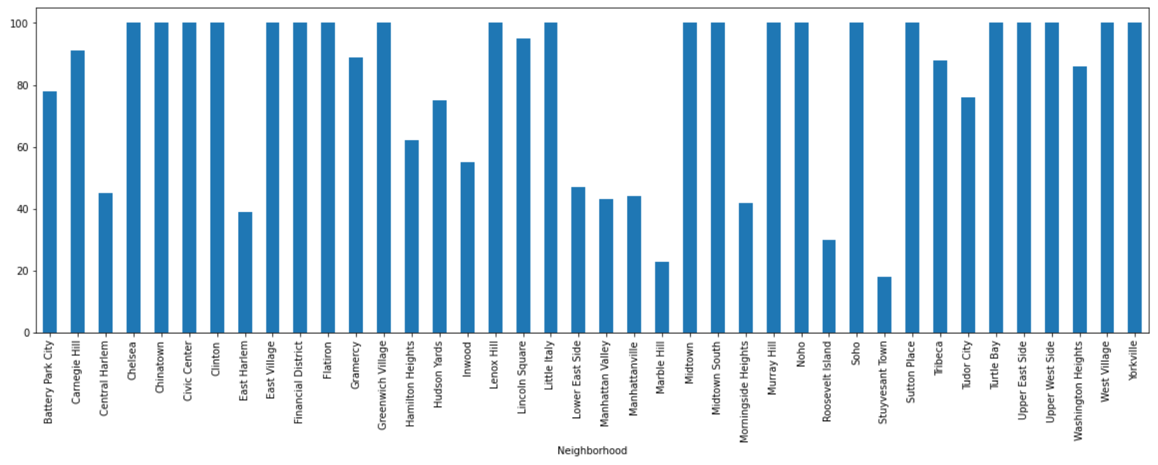

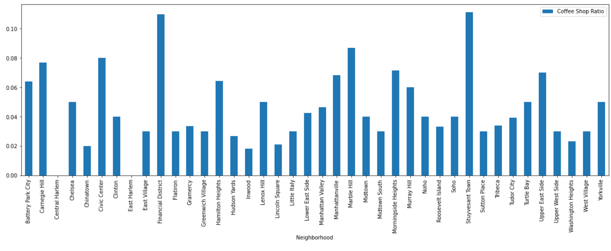

Conclusion:

In conclusion, while there may be some opportunities in Central of East Harlem, they are not home to many other venues and this probably reflects fewer business opportunities overall. Chinatown has both a large number of other businesses but a uniquely low ratio of coffee shops-- only 2%. There are of course many other variables, such as rent expense, population type (office workers vs residents vs tourists) and local taste, but I recommend looking into that neighborhood as a potentially good place to start up a new coffee shop.